|  |
| --- |
| Queensland University of Technology |
| **Personal Portfolio** |
| Pink Spoon – Group 15 |

|  |
| --- |
| James Uprichard – N10077596  5-4-2018 |

Table of Contents

**Artefact 1** – (Data Flow Diagram) 2

**Artefact 2** – (User Testing) 3

**Artefact 3** – (Database/Models) 5

**Artefact 4** – (Site Map) 6

**Artefact 5** – (User Registration) 7

# **Artefact 1** – (Data Flow Diagram)

The data flow diagram is used to map the flow of data of different processes through the website.

The diagram below shows the data flow for students/admin booking music lessons, these data flow diagrams contribute to the documentation of the project to show the development, project management teams and client the structure involved in each task that can be performed on the website.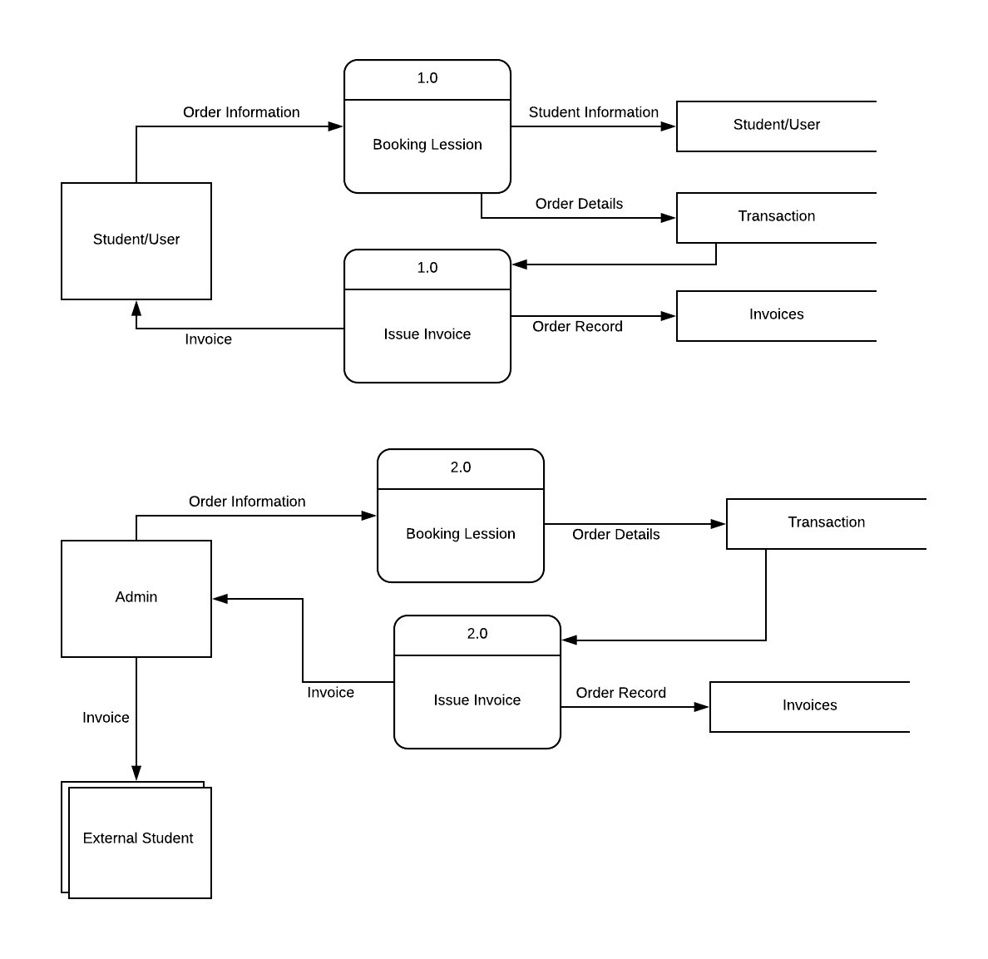

# **Artefact 2** – (User Testing)

User testing is important for development projects for quality and performance purposes.

The user testing below allocated to me as many other tests have been completed has a group artefact. Testing is used to show where the website is preforming and where improvements are needed to be made before the end product is live for users to use.

|  |  |  |  |  |  |  |  |
| --- | --- | --- | --- | --- | --- | --- | --- |
| Serial Number | Test Case Description | Entry Criteria | Exit Criteria | Expected Result | Actual Result | Test Date | Test Pass/Fail? |
| 001 | Confirm email is of valid format | When registration form is submitted email is passed through validation.  Only valid email addresses pass validation | If valid user email information is stored in the database with their other details | Email validation works successfully  Invalid email address results in invalid format message.  Record of user details displayed with valid email address | Email validation works successfully  Record of user details displayed with valid email address  Invalid email address results in invalid format message. | 04/05/18 | Pass |
| 002 | Unregistered user can navigate to sign up page | Register account button exists on homepage  When clicked, it redirects visitor to a form of required credentials to create an account. | After entering all credentials correctly, the visitor is redirected to the user dashboard.  If credentials are entered incorrectly, account registration form notifies which piece of information requires updating. | Visitor successfully creates account and becomes a user.  User dashboard appears after account creation. | Visitor successfully creates account and becomes a user.  User dashboard appears after account creation. | 04/05/18 | Pass |
| 003 | Password is hidden when being entered | When user logs in the password field is show as ******** | User password show as ******** | On login password is expected to show as ********* | Password filed show as ******** upon user login | 04/05/18 | Pass |
| 004 | Password is validated to meet minimum requirements | When user logs in the password field is show information for user to follow  Password is validated upon submission of the form | After the form in filled in correctly, the user password is added to the database.  The new user is added successfully | Password is validated upon submission of the form if valid user is created  If invalid password format users are prompted to correct invalid password field | User successfully creates account and becomes a user.  Validation of password field works correctly | 04/05/18 | Pass |
| 005 | Registering user data is entered into database | Valid registration information is stored in the database | After the form in filled in correctly, the user data is added to the database. | The user is data added successfully | The user is data added successfully | 04/05/18 | Pass |
| 006 | User can edit account details | When user is logged into their account user can navigate to (My Account) user details are edited on this page  Registration form validation applies to editing user details | After the form in filled in correctly, the user data is added to the database. | The user is data updated successfully  If invalid information fields prompt user to add valid information to continue with update of details | The user is data updated successfully  Validation worked successfully | 04/05/18 | Pass |
| 007 | User can log out | When user is logged into their account can navigate to the log out button | Clicking on log out the user is logged out of their account | Log out process logs out the user and redirects to the accounts logout page | Log out successful redirected to accounts logout page | 04/05/18 | Pass |

# **Artefact 3** – (Database/Models)

Database: Using MySQL as the DBMS (Database Management System) our team have used models to build the tables within the database schema for the website.

This provides a working database for the sprint 1 website that’s been developed. Currently the database can store users, admin, instruments and invoices to name some of the tables.

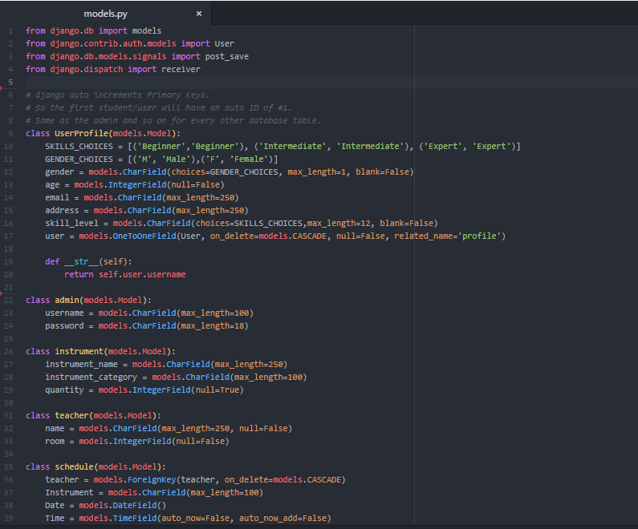

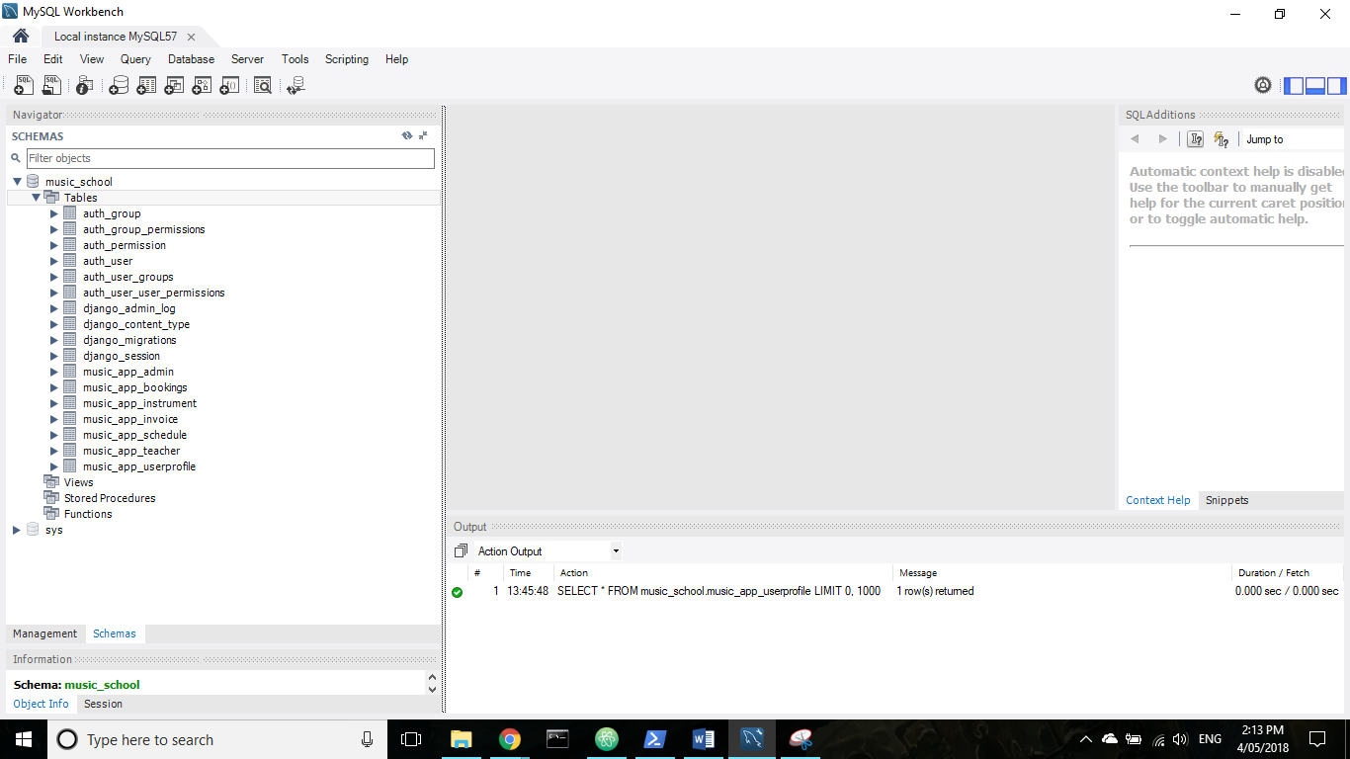

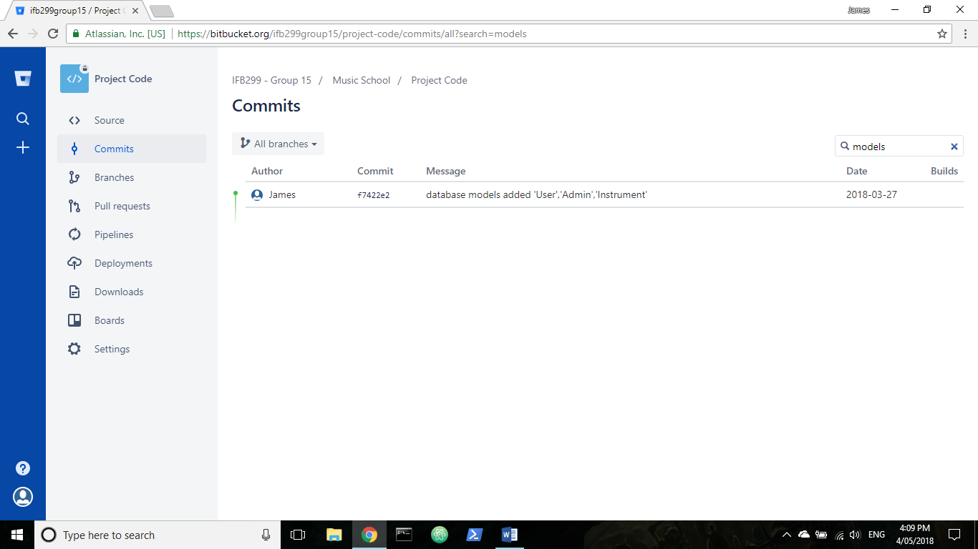

# **Artefact 4** – (Site Map)

The site map shows the outlay of the website and the interactive of processes.

This site map is the current layout of the website for pinelands music school for Sprint 1, our team has used the 3 clicks rule when building the website meaning a user can get from the home page to the account dashboard if the are a member in 3 clicks e.g. Login page, My Account Page, Dashboard.

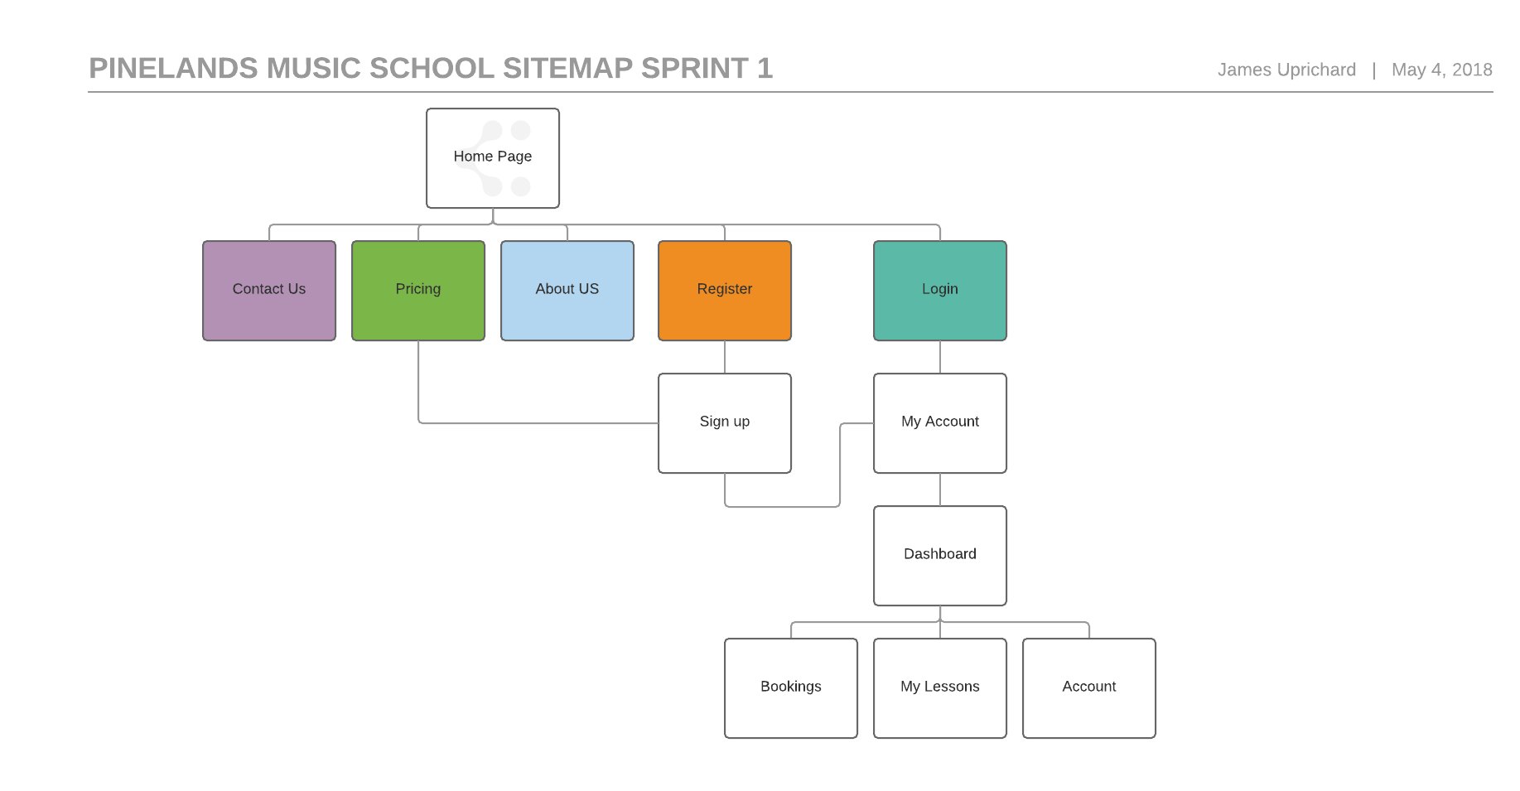

# **Artefact 5** – (User Registration)

The user registration form allows new users to sign up for accounts with the website, to book lessons and hire instruments for their music lessons if the user needs such things.

User registration is very important to the client, so users have an account for storing records of student information, hired instruments and booking lessons each week. Without this user registration form and process the project will not meet the client’s requirements for the website.

